8. MISSIONARIES CANNIBAL PROBLEM
Aim:
To solve the Missionaries and Cannibals Problem using the Breadth-First Search (BFS) algorithm in Artificial Intelligence.

Objective :
To safely transport three missionaries and three cannibals from the left river bank to the right river bank using a boat that can carry a maximum of two people, without ever allowing the cannibals to outnumber the missionaries on either bank.

Algorithm:

- Represent each state as (Missionaries Left, Cannibals Left, Boat Position).
- Initialize the starting state as (3,3,L).
- Define the goal state as (0,0,R).
- Generate all possible boat moves:
- Two missionaries
- Two cannibals
- One missionary and one cannibal
- One missionary
- One cannibal
- Check whether each generated state is valid.
- Use Breadth-First Search (BFS) to explore all valid states.
- Avoid revisiting previously explored states.
- Continue until the goal state is reached.
- Display the solution path.

Flowchart :

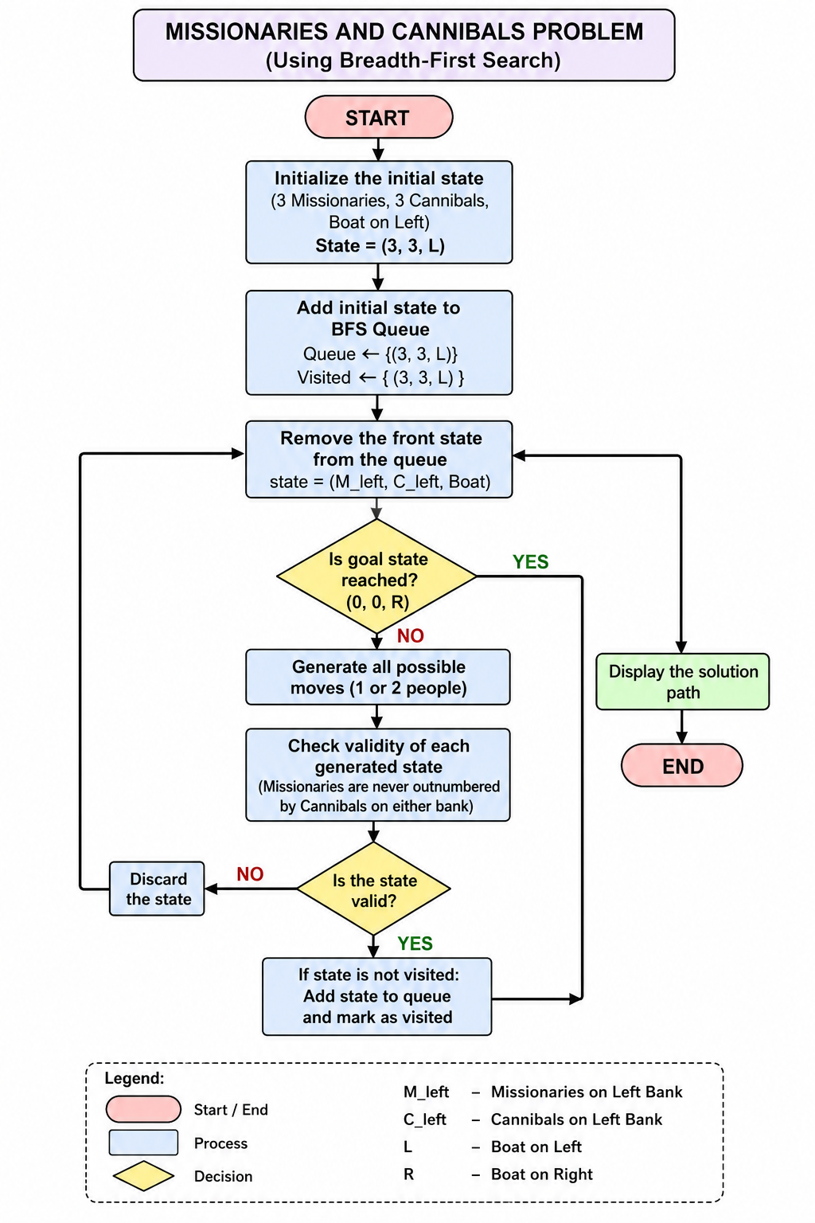

Code:

from collections import deque
def is_valid(m_left, c_left, m_right, c_right):
if m_left < 0 or c_left < 0 or m_right < 0 or c_right < 0:
return False
if (m_left > 0 and m_left < c_left):
return False
if (m_right > 0 and m_right < c_right):
return False
return True
def get_next_states(state):
m_left, c_left, boat = state
next_states = []
moves = [(2,0), (0,2), (1,1), (1,0), (0,1)]
for m, c in moves:
if boat == 'L':
new_state = (
m_left - m,
c_left - c,
'R'
)
else:
new_state = (
m_left + m,
c_left + c,
'L'
)
new_m_left, new_c_left, new_boat = new_state
new_m_right = 3 - new_m_left
new_c_right = 3 - new_c_left
if is_valid(new_m_left, new_c_left, new_m_right, new_c_right):
next_states.append(new_state)
return next_states
def bfs():
start = (3, 3, 'L')
goal = (0, 0, 'R')
queue = deque([(start, [start])])
visited = set()
while queue:
state, path = queue.popleft()
if state in visited:
continue
visited.add(state)
if state == goal:
print("\nSolution Found!\n")
for step in path:
ml, cl, boat = step
mr = 3 - ml
cr = 3 - cl
print(f"Left({ml}M,{cl}C) --- Boat:{boat} --- Right({mr}M,{cr}C)")
return
for next_state in get_next_states(state):
if next_state not in visited:
queue.append((next_state, path + [next_state]))
print("No Solution Found.")
print("MISSIONARIES AND CANNIBALS PROBLEM")
bfs()

Output:

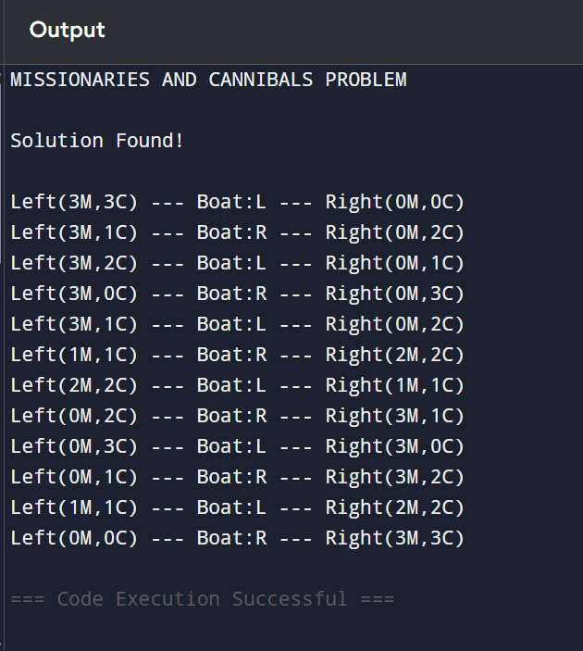

Result :

The Missionaries and Cannibals Problem was successfully solved using the Breadth-First Search (BFS) algorithm. The algorithm explored valid states systematically and found a safe sequence of moves to transport all missionaries and cannibals across the river without violating the problem constraints.

